1. Test Plan Identifier
File Name: 1.0_Indianrailways_tplan_v1.0.doc
Location: Hyderabad
2. Document History
REV | Author | Edits | Date
1.0 | Shivani.k,team leader,project manager | Initial Draft | 11/19/2024
- Introduction
Indian Railways is one of the largest and busiest rail networks in the world, playing a vital role in the transportation infrastructure of India. It is owned and operated by the Government of India, under the Ministry of Railways, and provides both passenger and freight services across the entire country.
4. Features to be Tested
Medium priority features are features that have been stable and High Priority features are features that have been recently changed.

Feature To be Tested | Priority | Comments
User Registration and Login | High
Train Search and Booking | High
Ticketing and Reservation
User Interface and Experience
Push Notifications and Alerts

4.Features NOT to be Tested
Help Contents and user manuals will not be tested.
Installation and presentation will not be tested.
Support of the other architectures also will not be tested.

5.Test Strategy
The test strategy for Indianrailways1.0 will include manual testing with automated testing where time/need permits. Automated testing will be used to test the basic Interface objects, keyboard and mouse navigation or any redundant tasks best translated to automation. Automated testing will be limited to a Win-64 platform because of Automation tool limitations.
- Sanity test will include an very short battery of tests to ensure the Indianrailways1.0 runs/launches and can connect to the back end database. Test execution will happen as individual component testing. These tests will be fully automated.
- Acceptance tests will include a short battery of tests that will only touch major features to ensure Indianrailways1.0 will operate smoothly at a basic level. These tests will be executed on Windows 98, Windows NT 4, Windows 2000, workstations and servers. The goal will be to automate all of these tests.
- Full Functional tests will include a comprehensive test of all features listed in this document. These tests will be limited to the Windows 2000 workstation client. These test will include automation with time allowing.
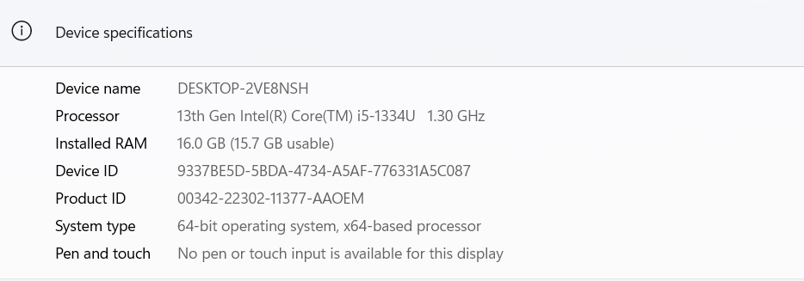

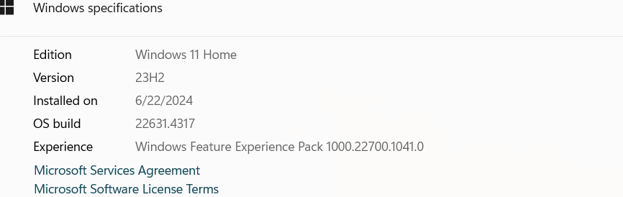

- Functionality Testing
Registration
Verify New Registration .
Verify Closing of the registration window.
Login
Train Search and Booking
Ticketing and Reservation
User Interface and Experience
Push Notifications and Alerts

Usability Testing
The usability testing will be accomplished by verifying the information in each window are accurate. Menus, icons and toolbar functionality will be tested as applicable to the navigation and results panes. Multi Window Overlapping will be tested because product supports opening of multiple documents.
Robustness/Reliability Testing
Test the GUI for correct keyboard and mouse navigation, windows, menus, buttons, etc. These tests will include Keyboard only navigation of Indianrailways1.0, Mouse only navigation. Correctness and existence of warning/error dialog boxes. The correct/expected functionality of buttons, icons and menus.

Stress Testing
Not applicable

7. Test Deliverables
Test plan 1.0_Indianrailways_tplan.doc
Test Specification 1.0_Indianrailways_tspec.doc
Test Automation Plan TBD
Test Checklist TBD
Test Logs TBD
Test tools Selenium Tool (ALM Tool) Application Lifecycle Tool

8. Testing Tasks & Resource Needs
Use of MS ACCESS database.
Write Test Specification.
Write Test Automation plan.
Write Test Checklist.
Setup workspace.
Develop Automation script.
Minimum requirements for platforms:
Intel: Intel ~400mz, with 96mb* of Ram for NT workstation client.
Intel ~400mz, with 64mb *of Ram for 98 workstation client.
(* Automation needs an additional 128MBs to function)

9.Schedule
Test Documentation
Document | Development Time |  | Sign-off Date | Dependencies
 | Person-Days | Completion Date
Test Plan | 1day | 20/11/2024 |  | Functional Spec. Review
Test Specifications | 1 day | 20/11/2024 |  | Testplan, Functional Spec, Review
Test Logs | TBD | 20/11/2024
Test Summary Report | TBD | 20/11/2024
Checklist | TBD | 20/11/2024

Test Development
Deliverable | Development Time |  | Dependencies
 | Person-Days | Completion Date | Chatgpt,browser
Functional Test Suite | 1 | 20/11/24
Automation build

Test Execution
Test Activity |  | Execution Time (Person-Days) |  |  | Dependencies
 |  | Alpha | Beta | FCS
Acceptance |  | 1 Day | 1 Day | 1Days
Functional | Functionality | 1 | 1
 | Usability | All High to Medium testcaces
 | Robustness | All High to Medium testcaces
 | Stress | All High to Medium testcaces
 | Multi Inst. | All High to Medium testcaces
Regression
Documentation Review |  | 1 | 1 | 1
Total Test Cycle |  | 1 | 1 | 1

- Risks and Assumptions
Risks:
Environment Instability: Delays in setting up the test environment could impact the schedule- VM is not working port no.-5103
Resource Availability: Limited availability of testers could delay test execution.
Late Requirement Changes: Changes in requirements during the testing phase could lead to additional testing efforts.
Contingencies:
Backup Resources: Have backup resources ready to join the testing effort if required.
Flexible Schedule: Allocate buffer time in the schedule to accommodate unexpected delays.
Regular Communication: Hold daily stand-up meetings to quickly address any issues that arise
11.Approvals \Sign of
POSITION  *Approval required | NAME | SIGNATURE | REVIEWED | APPROVAL
Tech Lead | Archana |  | Archana | Archana
Project Manager | Raghavendra |  | Raghavendra | Raghavendra
Client Approval | Micron |  | Micron | Micron

